A REVIEW OF NANOTECHNOLOGY APPLICATIONS IN THE OIL AND GAS INDUSTRIES

Title:
The title should appear below the top edge of the page. It should be brief, clear and descriptive. Use Times New Roman 12 bold letters, centred on the width of the typing area. Please use upper-case.
Petrov S.∗, Ivanov I.I. ²

¹ Saint-Petersburg National Research University of Information Technologies,
Mechanics and Optics University ITMO, St. Petersburg, Russia.
² National Research Tomsk Polytechnic University, Tomsk, Russia.

Information about authors:
Authors’ names, affiliations (organization, city, country), and e-mails should be Times New Roman 12 but not bold. Leave one blank line between the title and the affiliation(s).

For more convenient article processing and reviewing please follow the next requirements:
- Be typed in Microsoft Word;
- Be typed in Times New Roman (font size 12 pt, 25 mm margins, single line spacing without hyphenation, extra spaces and paragraph intervals).

Abstract
Please follow strictly the general pattern of abstract composition: problem formulation, concepts, actions taken, results obtained, significance/state of the art contribution.
Please avoid acronyms in the title, the highlights and in the abstract, unless they are very common – like CHP for “Combined Heat and Power”. Acronyms make these paper parts unclear.

Keywords:
Please supply six to eight keywords, which apply to your paper, after the abstract. For example: Process Integration, Energy, Process Industry, Emissions Reduction, Sustainability.

  - Introduction.
The introduction section should start with the general topic introduction.
Next follows the state of the art overview. This is a review of literature sources and other previous works, which are described, summarised and analysed. The analysis goal is to clearly show the progress of the current work beyond the state of the art. The lack of proper justification creates the wrong impression that the authors are unaware of the recent developments. Please use relevant recent references by OTHER authors published during the last 3 years.
After the overview, it is necessary to connect the state of the art to your paper goals. Please follow the literature review by a clear and concise state of the art analysis. This should clearly show the knowledge gaps identified and link them to your paper goals. Please reason both the novelty and the relevance of your paper goals.
References should be numbered consecutively in the order they are mentioned [1], using Arabic numerals [2] in square brackets [3]. Any use of lumped references as in [4-8] should be avoided to provide sufficient representation of the main contribution of each referenced paper. Instead, characterise each reference individually. This can be done by mentioning 1 or 2 phrases per reference to show how it is different from the others and why it deserves mentioning. This is not just formalism. Having reference lumps in the text casts serious doubt on whether the authors have read and understood the cited sources. If you do not characterise the references individually it matters little how they are formatted. What really matters is to have meaningful references and the requirement for individual characterisation aims exactly at that. Even the small lumps leave something unsaid and reduce the quality and impact of the paper.

2. Methodological sections.
This should start with a description of the scientific hypothesis, concepts and the relevant reasoning for choosing the particular modelling approach. This should be accompanied by an overall description of the followed procedure. The model description and any log of investigative/experimental actions should follow that. The methods proposed in the paper may include the following modelling elements:
• Assumptions
• Mathematical formulation – sets, constants, variables, equations, etc.
• Algorithms treating the other modelling elements
The model has to be presented clearly. Please avoid just listing the equations and defining the variables, stopping at that. For each equation, please add a concise explanation including the reasoning for its definition and how does it work internally and how does it work within the model context. Same goes for the algorithms.

Equations, units, symbols, etc.
Equations should be typed neatly in position with appropriate space above and below to distinguish them from the text. Equations should be either centred or placed flush left and assigned a number that should appear in parentheses to flush to the right margin.

Poisson’s equation (1D model magnetic field components and electric field transversal components are omitted):
^{, (1)}
the continuity equation for plasma electrons:
^{, (2)}
and the plasma electrons motion equation:
^{, (3)}

All data should be reported in SI units. Decimals should always be shown by periods and not by commas or centred dots. Examples of the correct form of data and units are 70%, 125 °C, 18 kg/s, 48.5 EUR/kWy etc.
All equation variables should be identified within the manuscript text in addition to their inclusion in the Nomenclature at the end of the manuscript to facilitate clarity of presentation.

Figures
All original drawings should be prepared, if possible, for a uniform scale of reduction. As a general rule, lettering in the figures should be comparable to that in the text.
Figures should be numbered consecutively, e.g. Fig. 1, with a single letter space between the word “Fig.” and the Arabic numeral. Place figures centred on the width of the text page and either at the top or bottom of the page as close as possible to their first mention in the text. Centred one line below the illustration, type the word “Figure” (in upper and lower case) and its number followed by a period and two-letter space. Then type the legend single-spaced, with an initial capital for the first word and proper nouns only.
Example:

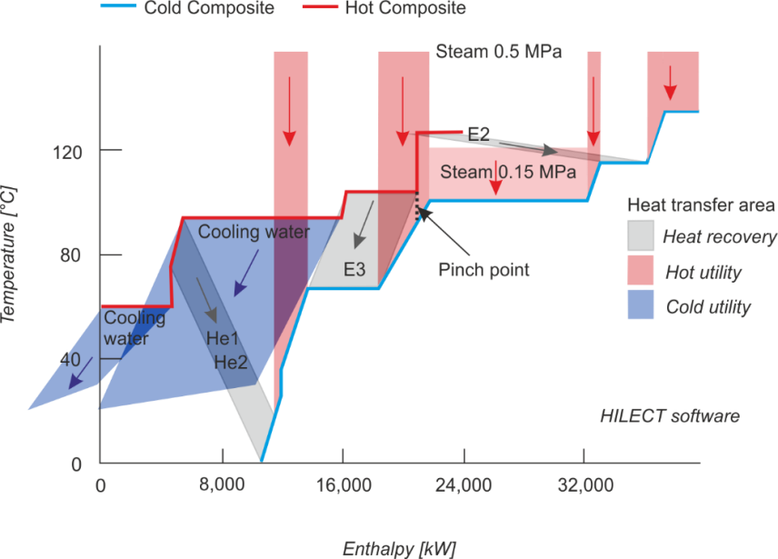
Fig. 1. Composite Curves of the evaporation unit

Tables
Table captions should appear above the respective table. Each table should have at least a one-line space both above the table and between the table and the start of the following text.
When tables are mentioned in the text, they should be referred to as Table 1, Table 5, i.e., with a single letter space between the word “Table” and the Arabic numeral.
The word “Table” should be capitalized, single-spaced and centred with the table number, followed by a period, two spaces and the table caption, above the table. Use horizontal rules above and below to separate title from column heads, ranks within column heads, column heads from table body, and table body from table footnotes or source. For example:
Table 1. Summary table
Model | Remark
- Simple porous model | - Simple to use in the analysis. Less complex in nature.
- Poles and zeros model | - Appropriate for frequency domain plot analysis, such as Nyquist plot and Bode diagrams.
- Structural model | - Introduces a complex set of constant phase elements, which captures more dynamics.
- RC parallel mode | - Slightly better than the simple porous model because dynamic changes due to leakage current are accounted for.
- Nonlinear Gohr's Model | - Nonlinear behaviour is handled better using this.
- Electrosorption  theory-based SC model | - Accounts for the nonlinearity induced because of electrosorption phenomenon

Acronyms/abbreviations/chemical formula.
Any acronym/abbreviation and/or chemical formula should be introduced when used for the first time in the main manuscript text. The order should be the full name followed by the introduced form in parentheses, such as Process System Engineering (PSE) and carbon dioxide (CO₂). All introduced forms of acronyms, abbreviations and chemical formula should be used consistently thereafter, including the conclusion. Acronyms, abbreviations or chemical formula should not be used in the title, abstract and section/subsection headings.

3. Case studies.
The case studies are used for two possible purposes:
(a) Validate your models and methods – adequacy, accuracy, modelling behaviour.
(b) Illustrate the applicability of the methods and the extent of the obtainable results.
One should use any of the parts as applicable to the presented work.

4. Results and discussion.
In many cases, the discussion of the methods and the case study results can be integrated into the case study section. However, in the case of more than one case study, a separate section on the discussion and analysis may be appropriate. In this section, the results can be summarised and analysed, keeping the discussion strictly within the validation and demonstration contexts.

5. Conclusion.
In the conclusions, in addition to summarising the actions taken and results, please do explain their significance. It is recommended to use quantitative reasoning comparing with appropriate benchmarks, especially those stemming from previous work.

Nomenclature
This is a necessary section in the case that the article features notations and symbols for mathematical models or any abbreviations. All such elements have to be listed in this section and their meaning clearly defined. For measurable quantities, the measurement units should be given. Generally, the SI units are recommended, unless the specific journal has other requirements – that has to be checked before each submission, consulting the guide for authors of the specific journal.
In some cases, as it is in the case of industrial utility systems and other chemical processes, the quantities may be expressed in custom measurement units, differing from any of the standardised unit sets used in the World. This is, for example, the case of steam flows, which are frequently expressed in t/h, while the SI unit for this is kg/s. In such cases, it may be good to give the custom units used in the respective engineering field, but also to provide the value in SI units, added in parentheses. These decisions should be made after careful consideration of the journal, maybe even consulting previously published articles in this journal, especially for the period of the last 2 years before the current manuscript is submitted.

Funding

Acknowledgements
Any acknowledgement of funding or sponsorship should be provided preferably in this format after the conclusion rather than a footnote with the indication of any grant numbers as applicable.
REFERENCES
For references please follow the instructions given below.

Web references
[1] World Energy Balances 2019, IEA. Available at: https://www.iea.org/reports/world-energy-balances-2019, accessed on 23.02.20.

Reference to an article
[2] Aleksandrov P.A. and Beloshitsky V.V. Charge exchange at grazing reflection of swift ions from a solid surface. Radiation Effects and Defects in Solids, 1991, vol.117, no. 1–3, pp. 95–98. doi: 10.1080/10420159108220599.

Reference to a book
[3] Silfvast W.T. Laser Fundamentals. Cambridge, Cambridge University Press, 2004, 601 p.

Reference to a conference
[4] Abidin Z.Z., Manaf M., Shibghatullah A.S., Anawar S.; Ahmad R. Feature extraction from epigenetic traits using edge detection in iris recognition system. IEEE International Conference on Signal and Image Processing Applications (ICSIPA), 2013, pp.145–149.

∗ Corresponding authors: Petrov S. E-mail: abc@yandex.ru

